Theme E:
Religion, crime
and punishment
Theme E: Religion, crime and punishment
Forgiveness- a chance to move on and move forward. To overcome issues and resentment.

Law and order- are about the rules we have in our society so it runs smoothly. These rules exist to try and keep society a calm and safe place. They are based on the ideas of right and wrong.

Justice- a belief in what is right and fair.

Suffering- a feeling of pain, harm, sadness either caused by oneself or others.

Conscience- the voice in our head that tells right from wrong. It is also feeling guilty for what you’ve done wrong.

Morality- a person’s belief of what is right and wrong in terms of behaviour and actions. Most people have a sense of morality from their own faith.

Sin- an act which goes against God’s will; a religious offence. This could be stealing, murder etc.

3 categories of crime

Causes of crime

Reasons for crime

Good is defined righteous and morally acceptable.
Evil is something that is immoral and wicked.
Good and evil

Buddhism sees good and evil as two inseparable aspects of life; you cannot have one without the other. Motivation to do evil comes from the Three Poisons: greed, anger and ignorance. Every person is subject to these, it is how they manage their thoughts and actions that impact on this. We are each responsible for our own actions and the consequences of these.

Buddhist views on evil

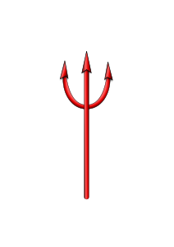

Evil is seen as the abuse of the free will that was given by God. This was then Adam and Eve betrayed God and went against Him. In order to be able to see and appreciate good, then evil needs to exist. Most Christians believe in Satan, who is an evil and turned away from God, however, he is less powerful than God. The Devil continually tempts people to commit evil acts and encourage them to behave badly, like the snake to Adam and Eve in the Garden of Eden. So evil is a combination of sin, temptation and human weakness.
Christian views on evil

The aims of punishment

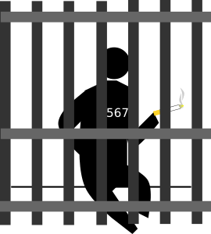
Suffering and religious attitudes

Suffering happens when people or events cause pain to themselves or others. It can be physical or emotional. Crime might directly cause suffering because it is done to you directly (for example, assault) or indirectly (for example, property or possessions being stolen.) In some places a country can suffer a crime against the State or a whole religion.

Victim support

When people are the victims of major crime, their names can be passed on to “Victim Support.” They can use this charity to overcome the effects of crime. Witnesses also get support, as the process of giving evidence can be traumatic, especially in a serious crime.
www.victimsupport.org.uk

Forgiveness
Forgiveness is a process that victims go through when they let go of the offence and the negative ideas of revenge, to move on and let the criminal move on too. Society deals with the actual crime through punishment. Forgiving someone is hard to do; sometimes they can forgive through words and the other times through actions.

In Christianity, forgiveness is very important as Jesus said we should forgive, “not seven times but seventy times seven.”

In Buddhism, forgiving practises two essential virtues compassion and understanding. Without these the world will be vengeful and troubled.

The treatment of criminals

Sentences | Description
Prisons (adult) | The UK has different types of prisons.  Category A&B are high security, Category C is for those serving shorter sentences and category D are open prisons for first-time offenders and those due to be released.
High security mental health institutions | Houses offenders with psychological or mental disorders, who threaten the safety of others and themselves. An example could be someone considered a psychopath.
Young Offenders Institutions | Houses offenders who are under 18 and aims to punish them as children/young people not adults.
Types of sentences | Description
ASBO | Anti Social Behaviour Order sets restrictions that the offender must stick to, for example, curfew or not going to certain places.
Community Service | Unpaid work in the community, for up to 300 hours. They might work in an area they’ve committed the crime e.g. picking up litter for littering offences.
Curfew | Must return home by a set hour, often used with tagging.
Electronic tagging | An electronic device attached to their leg that tracks where they are.
Fines | Money paid for an offence.
Probation | Offenders must meet regularly with a probation officer who monitors their behaviour.
Restorative Justice | Young offenders attend sessions to look at their crime, why it was wrong and its effect on the victim. They will often meet face to face with their victim to move forward.
Attitudes of religions to offenders

Christianity
Christians believe the law has a responsibility to punish and care for the criminal whilst trying to reform them. Prison not only removes freedom but can also cause problems for families and relationships. Christians have issues with some harsh punishments as they try and promote love and reformation. Although some Christians want focus on justice and “an eye for an eye” teaching from the Bible. However, most Christians do believe in people being treated fairly and humanely.
Buddhism
The law enforces rules and punishes when rules are broken. Punishment is a deterrent to put off criminals, Buddhists believe that motive is wrong and we should not commit crimes because we think and act in the right way by thinking about the consequences of our actions. They disagree with some punishments that do not show love and compassion or harm to others. The Buddha didn’t talk about the types of punishment that were acceptable for the different types of crimes.

Parole- means that a person can be released early having served some of their sentence. When on parole, they must live within the law and are supported by a parole officer, who will help them integrate into society. The parole board might give them support for an addiction in order to stop them reoffending.
Parole

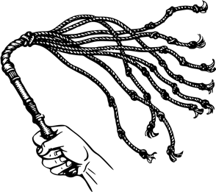
Corporal Punishment
Corporal punishment is to use physical pain as a punishment for a criminal act. It deliberately causes pain through whipping, branding or removal of a body part (amputation.) For example, some Middle Eastern countries chop off hands for stealing to deter people from stealing.

This type of punishment only remains in parts of Africa, the Middle East, Asia and South America.

Al religions believe life is sacred and should be respected.

Buddhism’s views on corporal punishment
Buddhists don’t believe they should harm any living being and corporal punishment causes harm.
Buddhism believes that cruel treatment of an offender does not make right what they did, and does not improve them. It also harms the person giving the punishment as they could receive bad karma.

Capital Punishment
Christian views on corporal punishment
Most Christians do not agree with it, believing in it does not help reform criminals, because it is more about retribution and taking revenge. Jesus himself was flogged before he was hung on the cross. The quotation “and a road for a fool’s back.” (Proverbs 26:3) and Psalm 89, “I will punish transgression with the rod” allow some Christians to justify physical punishment of children. Christian countries do not have corporal punishment.

Arguments for capital punishment | Arguments against capital punishment
An “eye for an eye, life for a life” means that murderers should pay with their life. | Retribution is uncivilised; two wrongs do not make a right. It’s hypocritical to condemn murder then take away the murderers life.
It is a deterrent; therefore it puts people off committing horrendous crimes. | Capital punishment would not be deterred as most people kill in the spur of a moment.
It brings justice. | Victim’s families will still grieve. It will not make them feel better.
Life sentences do not mean life, many murderers are set free an average of 16 years. | Innocent people could be executed.
It is a waste of resources housing criminals for their whole life. | All life is sacred and murderers should be given a chance to reform.
It’s the only way to protect society from dangerous criminals. | It is inhumane to put people through the mental torture of “Death Row.”
The Principle of Utility states that an action is right if it brings happiness to the greatest amount of people. | Happiness isn’t always what is considered right.

Amnesty International was founded in 1961 by Peter Benson who was a British Lawyer. Today it is the world’s biggest human rights organisation and campaigner. It informs the world about human rights abuses and campaigns for individuals and political change. It completely disagrees with execution and sees it as wrong and cruel. The organisation campaigns to end all human rights abuses and recognises the value of ALL human life.

www.amnesty.org.uk

Buddhist views on capital punishment
Buddhism teaches that people should follow the laws of the country in which they live. The Noble Eightfold Path tells Buddhists how to live their life in the correct way. A life of crime breaks the First Precept of “Do not harm others.” They believe our motivation to commit crime would be because of our human sin. Breaking the law would lead to bad karma and this affects future rebirths and limits the chance of enlightenment.

Buddhism teaches:
- All people are capable of change.
- Suffering is caused by attachment.
- The Three Poisons (greed, hatred, ignorance) causes evil action.
- The law of karma- the total of good and bad actions.
- Buddhists should practise Metta (loving kindness) and Karuna (compassion.)

Although Buddhists teach that all people can change, they recognise the need to punish criminals. They believe imprisonment should not prevent the criminal from being able to reform.

Christian views on
capital punishment

Christian teaches that the laws of a country should be followed unless they are unjust. For Christians, law breaking would therefore mean they were committing sins as well as crimes. This could affect them in the afterlife because they believe they will be judged by God in the afterlife. He will decide who goes to Heaven.
Christianity teaches:
- Christian love (agape) should be shown to all people.
- Jesus said to “Love your neighbour” (Mark 12:30-31)
- The 10 Commandments guides behaviour
- Forgive your brother 70 x 7 times (Jesus- Matthew 18:22)
- The Lord’s Prayer recognises/teaches forgiveness

Christians believe that offenders should be punished but punishments must be fair and just. The story of the Fall (Adam and Eve) shows that human nature is such that everyone sins.

chris

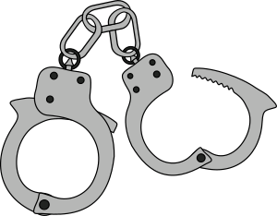
Religion | Topic: Corporal punishment
Christianity- Against | Christianity doesn’t accept corporal punishment. This is based on the concept of human dignity. Any form violence breaches this. They believe that violence will not solve violence and criminals dealt in this way will not reform.
Christianity- For | Some Christian groups allow parents to psychically chastise their children for misbehaviour. This follows the teaching in Proverbs “Whoever spares the rod hates their children, but the one who loves their children is careful to discipline them.” (13:24)
cONTRASTING BELIEFS

Religion | Topic: Death Penalty
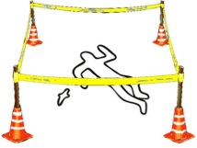  Christianity | Christianity generally disagrees with capital punishment. It is seen as going against the commandment “Do not kill” because a life is taken away intentionally. It also goes against the sanctity of life because the criminal is not treated with dignity. There is no chance of changing a person when the person is dead.
Christianity- For | Some Christians believe it is right to use the death penalty for those criminals who have committed the worse crimes e.g. murder. Since they have taken life, then their life should be taken also “An eye for an eye” (Exodus 21:24)
Religion | Topic: Forgiveness
Buddhism | Buddhism recognises that whilst forgiveness is the ideal, it can be very difficult to give. When someone has suffered, the negative emotions they hold can prevent them from forgiving.
Christianity | Forgiveness is a central teaching of Jesus. When asked how often a person should forgive, in Matthew 18:22 he said “70 x 7” which means always forgive. The Lord’s Prayer “Forgive us our trespasses as we forgive those who trespass against us.” Jesus’ crucifixion was necessary so that humans could be forgiven for their sins and enter eternity with God. Humans must try and follow Jesus’ example, so should be forgiving.
Christianity | Some Christians, who have been victims of very serious crime- for example, having a family member murdered- do not see a way to forgive. They seek justice rather than forgiveness for these serious crimes.

